1. Load a CSV file containing daily temperature data for Ahmedabad and create two new features: a 3-day lag of the temperature and a 7-day rolling average of the temperature using pandas.
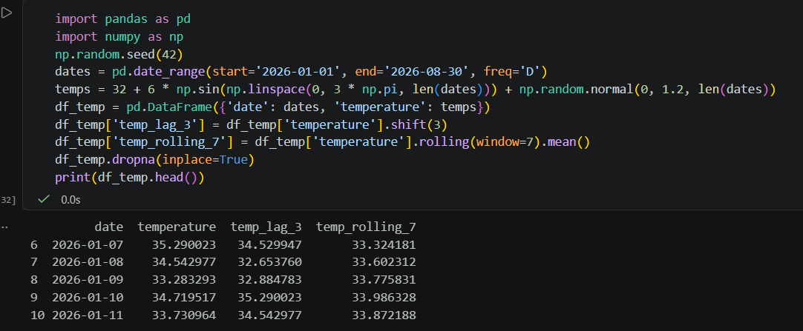

2. Extract date-time features from a Flipkart-style sales dataset (order_date column): create new columns for day of week, month, and whether the day is a weekend using pandas.
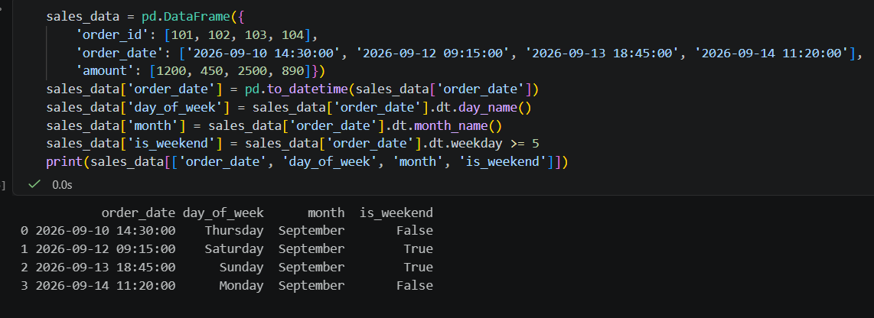

3. Train a Random Forest Regressor to forecast the next day's temperature using the lag and rolling features you created earlier. Print the predicted value for the next available date.
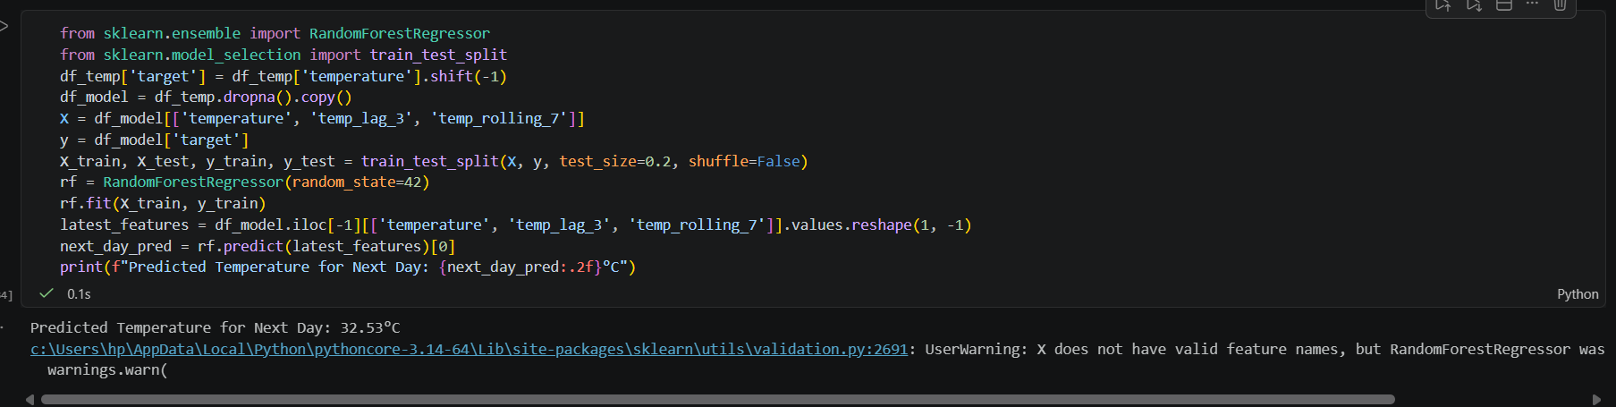

4. Calculate MAE, RMSE, and MAPE between your model's predictions and the actual values for the test set. Print all three metrics and explain in one line which metric is most sensitive to large errors. Use sklearn.metrics.mean_absolute_error, mean_squared_error, and write a simple function for MAPE.
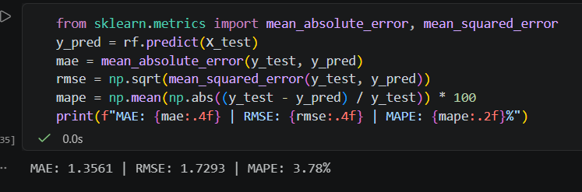

5. Use ChatGPT or Copilot to help you write code for calculating SMAPE (Symmetric Mean Absolute Percentage Error) for your time series predictions. Paste the code you used and mention one thing you learned from the AI's explanation.
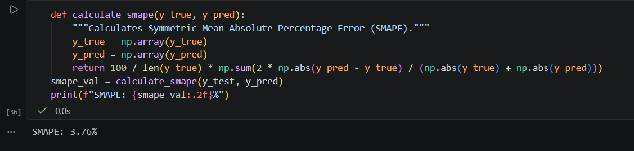

Thing Learned from AI Explanation: SMAPE bounds percentage errors symmetrically between 0% and 200%, solving the asymmetric penalization issue standard MAPE encounters when actual data points approach zero.

